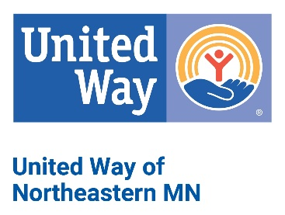

Endorsement Letters: CEO/LEADERSHIP

Below is a sample endorsement letter to promote your United Way campaign in the workplace. Be sure to put this on your company letterhead and personalize it whenever possible for greatest impact.

Dear (EMPLOYEE NAME):

As we kick off our annual United Way campaign, I ask you to join me in Helping Children Succeed, Empowering Healthy Lives, and Stabilizing Families and Individuals across our region by supporting United Way of Northeastern Minnesota (UWNEMN).

UWNEMN has a proven record of creating long-lasting positive impact in our communities.
When you donate to UWNEMN, you are supporting local non-profit agencies as well as UWNEMN programs like Buddy Backpacks, Imagination Library, and United for Veterans which have all been implemented or created by UWNEMN because of community members like you voicing a need.

With UWNEMN, you can be certain your donation stays local and is invested in local people and programs. Hundreds of volunteers unite each year to make sure every local United Way program and partner agency is well-run, efficient, and – most importantly – gets results.

When you give to UWNEMN, you are making a difference for your friends and neighbors – and improving the quality of life for us all. I encourage you to learn more about our local United Way’s work and impact at www.unitedwaynemn.org.

(COMPANY) and I personally support United Way of Northeastern Minnesota. I’ve seen the great things that happen because we Give Where We Live and encourage you to give through the employee campaign this year.

Sincerely,

(CEO/LEADERSHIP NAME, TITLE & SIGNATURE)

